Pre Calc Name: ______________

______________ ______________

WS Assessment

Target 19

The concept of limit

Finding limit graphically

* Concept of limit
* Finding limit by graph

HW 19 Concept of limit deltamath.com

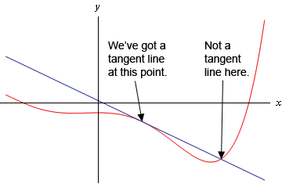A tangent line to the function f(x) at the point x = a is a line that just touches the graph of the function at the point in question and is “parallel” (in some way) to the graph at that point.

Now find the tangent line to f(x) = 15 – 2x2 at x = 1

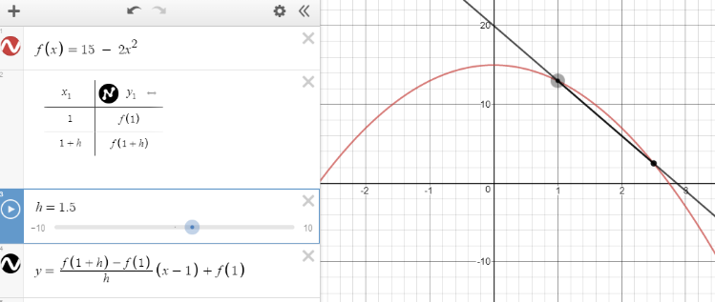 Tangent point?

When h = 1.5

The secant line has slope

$m=\frac{f\left(2.5\right)-f(1)}{1.5}$ = ?

|  |  |  |  |  |  |
| --- | --- | --- | --- | --- | --- |
| h | 1 | 0.5 | 0.05 | 0.005 | 0.0000…00001 |
| Slope m | ? |  |  |  |  |

To get the slope of the tangent line, we make h become very very small, almost zero.

We say as h goes to zero, the secant line become the tangent line, with the slope

$m=\lim_{h→0}{\frac{f\left(1+h\right)-f(1)}{h}}=$ work this out

The equation of the tangent line is y =

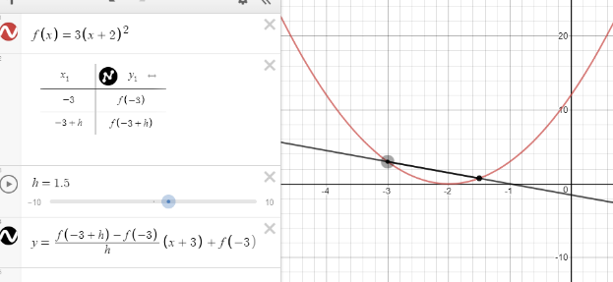You do. Find the tangent line to f(x) = 3(x + 2)2

at x = -3 Stamp

Limit – an Intuitive Approach

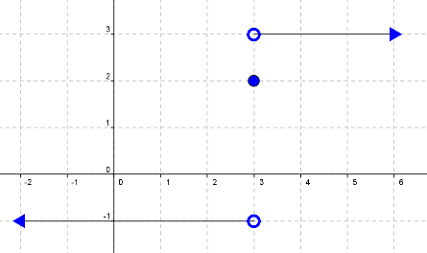For the function f graphed in the accompany figure, find

$\lim_{x→3^{-}}{f\left(x\right)=}$ $\lim_{x→3^{+}}{f\left(x\right)=}$ f(3) =

$\lim_{x→3}{f\left(x\right)=}$ $\lim_{x→-∞}{f\left(x\right)=}$ $\lim_{x→∞}{f\left(x\right)=}$

Write and find the limit on left, right and at the given point as well as infinity for the following graph

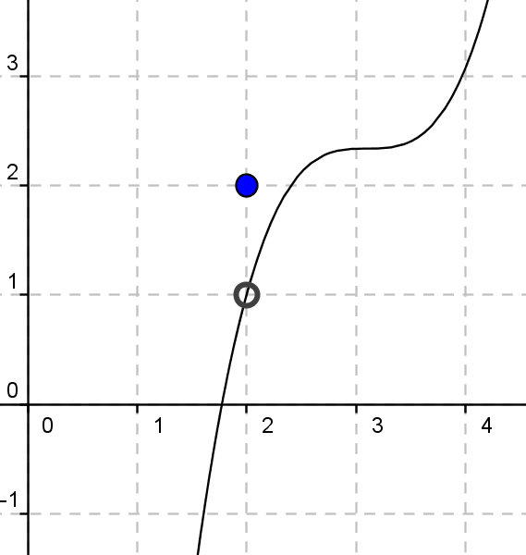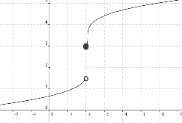

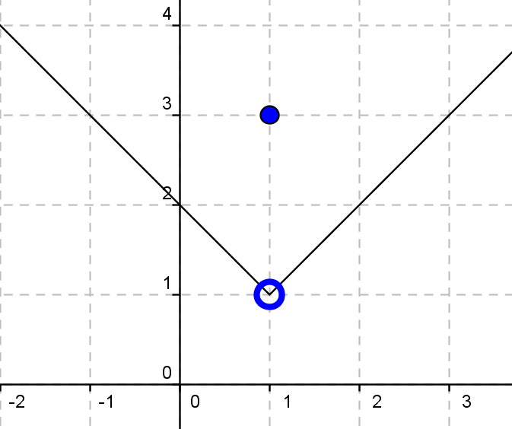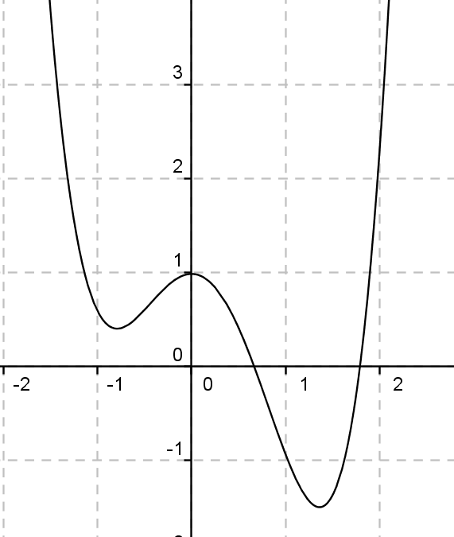

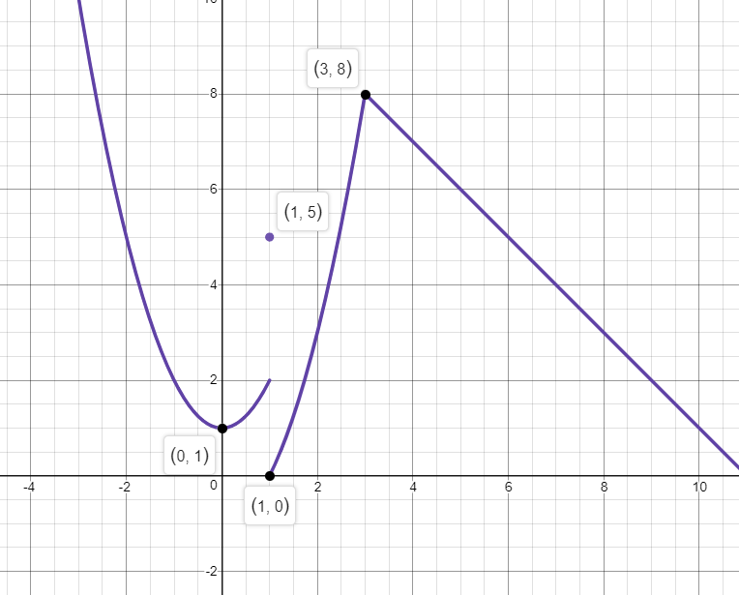Graph this function and write the limits at the given point (x = 0; 1; 3) Stamp

Using graphing calculator find the limit of the following

$\lim_{x→2}{\frac{x+1}{x-1}=}$ $\lim_{x→1}{\frac{x+1}{x-1}=}$ $\lim_{x→2}{\frac{x^{2}+2x-3}{x-1}=}$ $\lim_{x→1}{\frac{x^{2}+2x-3}{x-1}=}$

$\lim_{x→1}{\frac{\sqrt{x+1}-1}{x}=}$ $\lim_{x→∞}{\frac{\sqrt{x+1}-1}{x}=}$ $\lim_{x→-∞}{\frac{\sqrt{x+1}-1}{x}=}$

Sketch the graph with the following properties (show screen for stamp)

$\lim_{x→3^{-}}{f\left(x\right)=3}$ $\lim_{x→3^{+}}{f\left(x\right)=}3$ f(3) = 4

$\lim_{x→-∞}{f\left(x\right)=}$ $∞$ $\lim_{x→∞}{f\left(x\right)=}$ $-∞$

$\lim_{x→{-2}^{-}}{f\left(x\right)=-}∞$ $\lim_{x→{-2}^{+}}{f\left(x\right)=}∞$

$\lim_{x→2^{-}}{f\left(x\right)=}∞$ $\lim_{x→2^{+}}{f\left(x\right)=}-∞$

$\lim_{x→-∞}{f\left(x\right)=}$ $0$ $\lim_{x→∞}{f\left(x\right)=}$ $1$

$\lim_{x→0^{+}}{f\left(x\right)=-}2$ $\lim_{x→0^{-}}{f\left(x\right)=}1$ f(0) = -1

$\lim_{x→2^{-}}{f\left(x\right)=}∞$ $\lim_{x→2^{+}}{f\left(x\right)=}-∞$

$\lim_{x→-∞}{f\left(x\right)=}$ $4$ $\lim_{x→∞}{f\left(x\right)=}$ $3$

**Target 19 Assessment**

Find the tangent line to f(x) = -2(x + 3)2 at x = -2 Show secant/tangent line for stamp

Show me the graph with the following properties for stamp

